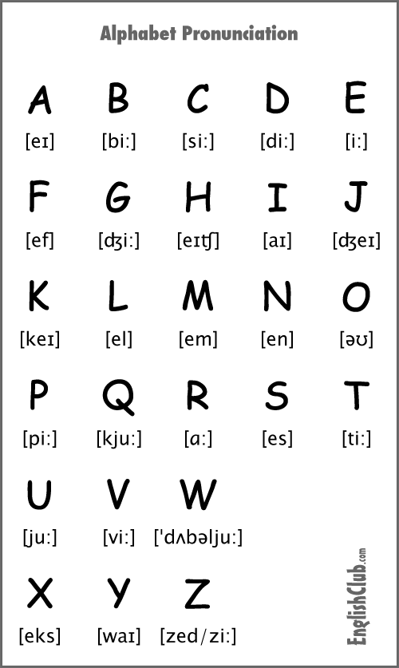**The alphabet**

**Numbers**

Practice:

One Eleven

Two twelve

Three thirteen

Four fourteen

Five fifteen

Six sixteen

Seven seventeen

Eight eighteen

Nine ninteen

Ten twenty

**What time is it?**

It’s 8 A.M. (You can also say "it’s 8 o’clock in the morning)

It’s 9:14 P.M. (You can also say "it’s 09:14 at night)

It’s 7:30 P.M. (You can also say "it’s seven thirty at night)

It’s 4:30 A.M. (You can also say "it’s four thirty in the morning)

I’ts 3:12 P.M. (You can also say "it’s three twelve in the afternoon)

**Days of the week**

DAYS OF THE WEEK

Lunes - Monday

Martes - Tuesday

Miercoles - Wednesday

Jueves - Thursday

Viernes - Friday

Sabado - Saturday

Domingo - Sunday

TIMES OF THE DAY

In the morning

In the afternoon

In the evening

At night

PREPOSITIONS OF TIME

in, on & at

“I go to the park on Saturday at ten in the morning”

“I go to school on Monday at nine in the morning”

“I go to the gym on Wednesday at two in the afternoon”

“I go to the restaurant on Friday at eight thirty at night”

**Introducing yourself**

Hello my name is Edwin and my last name is Jimenez

I am 24 years old, I am from CR, I studied software engineering in the UTN, I consider myself as a responsible person, currently I am working on encora company as web content specialist since 2019, in 2020 I finished my career and currently I have a bachelor degree and I am looking for a better opportunity that help me to increase my knowledge and experience.

**HELLO AND GOOD BYE**

Greetings

Hi

Hello

How Are You?

Good Morning

Good Afternoon

Good Evening

Farewells

Bye,Good bye

see you later

Take care

**Verb to be**

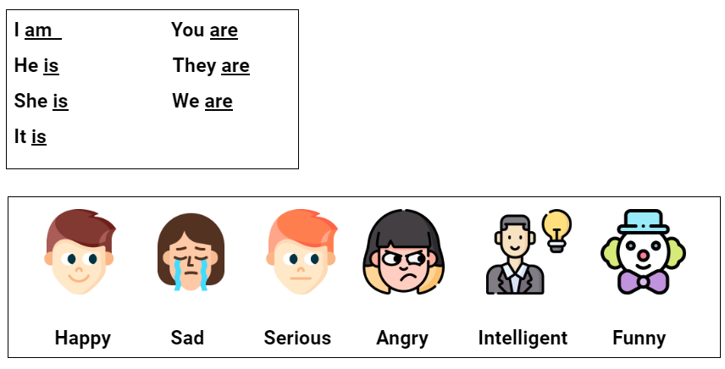

**Practice:**

He is angry.

They are funny.

You are serious.

I am happy.

She is intelligent.

**Jobs and personality**

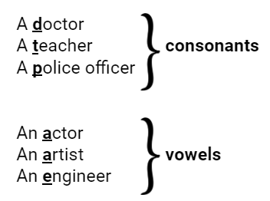

**Practice:**

She is a nurse

He is a dancer

She is an athlete

She is a developer

I am an architect

**Places**

**Prepositions of place**

**Hobbies**

**A**lways use the preposition “I like to” and them write your favorite activity

**Examples:**

I like play video games

I like to see the tv

I like to listen to music

**Like and dislike**

I like play video games

I like to see the tv

I like to listen to music

I do not like play video games

I do not like to see the tv

I do not like to listen to music

**Adverbs of frequency**

Always = Siempre 100%

Usually = Casi siempre 90%

Frequently = Frecuentemente 80%

Often = A menudo 70%

Sometimes = Algunas veces 50%

Occasionally = Ocasionalmente 30%

Seldom = Rara vez 10%

Never = Nunca 0%

An important thing to know is that never, seldom, rarely, hardly ever and ocassionally are not used in negative sentences. For example:

Don’t say I don’t never eat brakfast

Vacabulario nuevo:

Farewells

Greetings

cushions